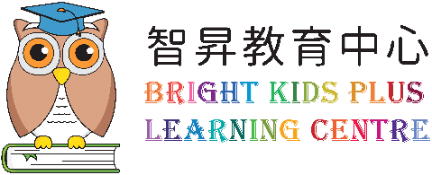

P1
English revision exercise

(first term exam revision)

Name: _________________________

Part A. Ken is introducing his school life. 
Circle the correct answer.

My name is / am / are Ken.
I is / am / are six years old.
I go to Sir Ellis Kadoorie (S) Primary School.
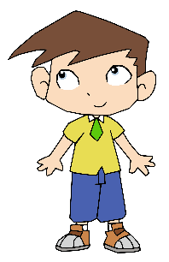

This is / am / are Andy.
It / She / He is my best friend.
It / She / He is our / my monitor.

This is / am / are Susan.
It / She / He is my classmate
I / We / You are in Class 1C.

Part B. About yourself. 
Answer the questions in complete sentences. 

1. What is your name?

2. How old are you?

3. Who is your best friend?

Part C. Match the two parts.

1. How are you? |  |  | A. My name is Coco.
2. What is your name? |  |  | B. Good morning, Jim.
3. Good morning, sir. |  |  | C. Nice to meet you too.
4. Nice to meet you. |  |  | D. I am fine, thank you.

Part D. Tommy is writing a birthday card to his Dad. Fill in the names and tick the box of the correct answer on the card.

Dear ______________________________________,

Good morning!

Nice to meet you!

Thank you!

Happy Birthday!
Love,

________________________

Part E. Jim is talking with Miss Chan and his classmates. Read the dialogue. Circle the best answer.

e.g. Good morning, (boys and girl / Miss / sir). I am Miss Chan.
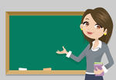

Miss Chan

1. (Good morning / Good afternoon / Goodbye), Miss Chan.
2. I am (fine / Jim / sir).
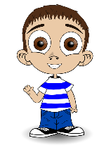

Jim

Hello, Jim
3. My name is (a boy / six years old / Tommy).
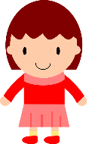
This is Ann.
4. (He / She / It) is my sister.

Ann
Tommy
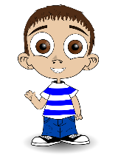
Hello, Ann.
5. How are you (! / . / ?)

6.
Jim

6. I am (three years old / too / fine), thank you.
Ann
Tick the best answer.

7. Who is Miss Chan?

 | A. She is a student. |  | B. She is Jim’s friend.
 | C. She is a teacher. |  | D. She is Jim’s sister.

8. Who is Ann? She is Tommy’s ____________________.

 | A. teacher |  | B. friend.
 | C. brother |  | D. sister

9. What is a classmate?

 | A. a teacher |  | B. a friend in your class
 | C. a sister |  | D. a boy

Part F. Read the form. Underline the mistakes and write the correct answers.

e.g. Fred: good morning, Gigi. My name is Fred. | e.g. Good
Gigi: Nice to met you. | 1.
Fred: Nice to meet you, too? How old are you? | 2.
Gigi: I am six year old. | 3.
Fred: This is our class teacher. He is Miss Chan. | 4.

Part G. Fill in the form of your class. 

1. _____________________________________________ School

Class: 2. ________________________________

Class teacher: 3. ________________________________

English teacher: 4. ________________________________

Monitor: 5. _________________________________

Part H. Fill in the blanks with ‘a’ or ‘an’

1. This is __________ bird in the sky.

2. Joe has ___________ egg.

3. Mum makes ___________ apple cake.

4. I have ____________ toy elephant.

5. He buys ______________ big orange.

Part I. Write down numbers 1-10.
1 _________________
2 _________________
3 _________________
4 _________________
5 _________________
6 _________________
7 _________________
8 _________________
9 _________________
10 _________________

Part J. Look at Wendy’s desk. Then complete what she says.

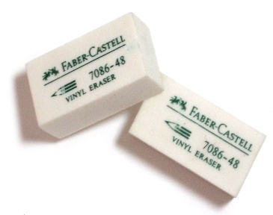
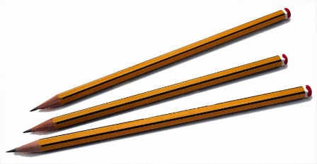
未知的作者 的 此相片 已透過 CC BY-SA 授權
未知的作者 的 此相片 已透過 CC BY-NC-SA 授權

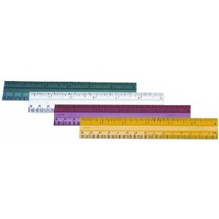
未知的作者 的 此相片 已透過 CC BY-NC-ND 授權

I have _____________ pencils and _______________ earsers.

I have ___________ ____________ __________ _________ _________.

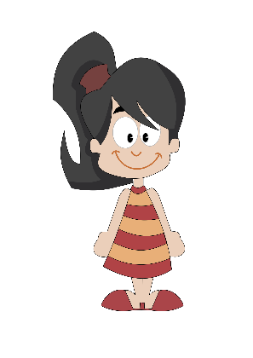

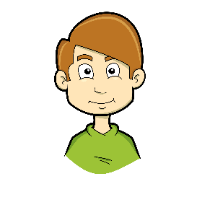
Part K. Look at the pictures. Then complete the sentences.

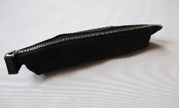
未知的作者 的 此相片 已透過 CC BY 授權

He has _______ ____________ ____________.

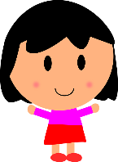
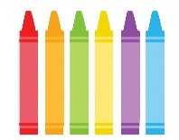
She ________ ____________ ________________.

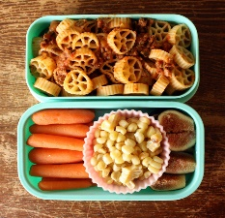
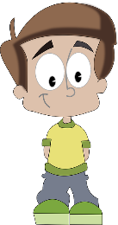
未知的作者 的 此相片 已透過 CC BY-SA 授權
未知的作者 的 此相片 已透過 CC BY-NC-SA 授權

__________________________________________________________.

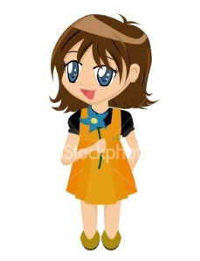
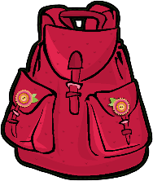

__________________________________________________________.

Part L. Below are six things that appear in the classroom. What are they?
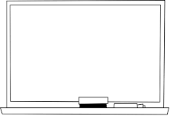 | 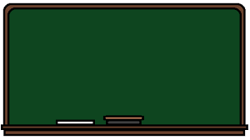 | 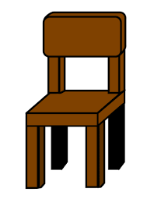
e.g. a whiteboard | a ___ ___ ___ ___ ___ ___ ___ ___ ___ ___ | a ___ ___ ___ ___ ___
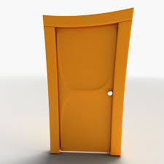 |  | 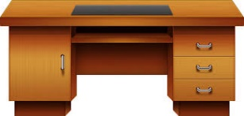
a ___ ___ ___ ___ | a ___ ___ ___ ___ ___ ___ ___ ___ | a ___ ___ ___ ___

Part M. Miss Lam is giving some instructions to students. Finish the sentences.
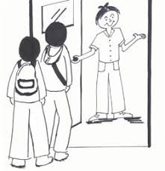

____________ ________, please.
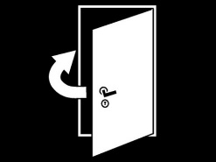

__________ the _______________, please.

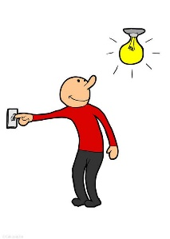

_________ ________ the ____________, ______________.

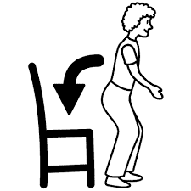

_______________________________________________.

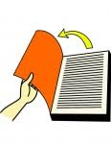

_______________________________________________.

Part N. Mary is reading a story. Read the story.
May sees a long box. ‘What is this?’, May says. Amy says, ‘This is my new pencil case. It is pink and yellow. I have four pencils and three erasers. I am happy.’ May has no new things. She says, ‘I am happy too. I can see new things. I see a blackboard, six windows and two fans. I love my classroom!’
- Match the correct numbers to the things.
 |  | - 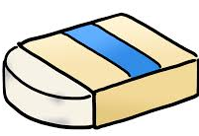 | - 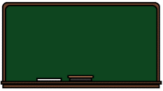
● | ● | ● | ●
● | ● | ● | ●
1 | 3 | 4 | 6

- Blacken the circles (●) for the best answers.
- What does the long box mean?
○ A. ruler | ○ B. school bag
○ C. pencil case | ○ D. door
- Who feel(s) happy?
○ A. May | ○ B. Amy
○ C. May and Amy | ○ D. No girl

